**Exercises 3.1: pp 86-89 Exercises 1-85 odd**

**Question#1**

**Question#3**

**Question#5**



**Question#7**

**Question#9**



**Question#11**



**Question#13**

**Question#15**

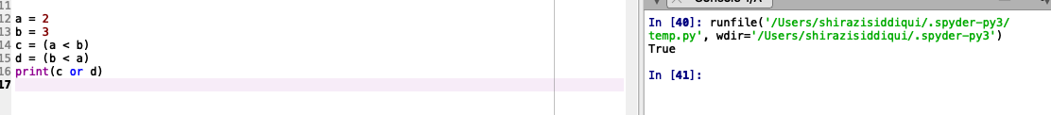

**Question#17**



**Question#19**

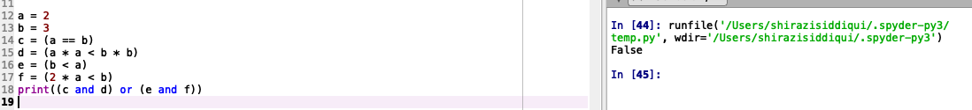

**Question#21**



**Question#23**



**Question#25**



**Question#27**

**Question#29**

**Question#31**

**Question#33**

**Question#35**

**Question#37**

**Question#39**

**Question#41**

**Question#43**

**Question#45**

**Answer is Equivalent**

**Question#47**

**Answer : Not Equivalent**

**Question#49**

**Answer : Equivalent**

**Question#51**

**Answer : Equivalent**

**Question#53**

**Answer : Equivalent**



**Question#55**

**Answer :** a > b is equivalent to the negation of **a <= b**

**Question#57**

**Answer :** (a < b) and (c != d) is equivalent to the negation of **((a >= b) or (c == d))**

**Question#59**

**Answer : a <= b is equivalent to the negation of a > b.**

**Question#61**

(ans== 'Y') or (ans == 'y') or (ans == "Yes") or (ans == "yes")

**Answer: ans in ['Y', 'y', "Yes", "yes"]**

**Question#63**

(year == 2010) or (year == 2011) or (year == 2012) or (year == 2013)

**Answer: 2010 <= year <= 2013**

**Question#65**

(n >= 3) and (n < 9)

**Answer: 3 <= n < 9**

**Question#67**

(n <= 10) and (n > –20)

**Answer: -20 < n <=10**

**In Exercises 69 through 84, determine whether True or False is displayed.**

**Question#69**

**Question#71**

**Question#73**

**Question#75**

**Question#77**

**Question#79**

**Question#81**

**Question#83**

**Question#85**

**Rewrite the following statement using the chr function instead of escape sequences.**

**print("He said \"How ya doin?\" to me.")**

**Exercises 3.2 pp 98-104 Exercises 1-43 odd**

**Question#1**

**Question#3**

**Question#5**

**Question#7**

**Question#9**

**Question#11**

**Question#13**

**In Exercises 15 through 18, identify the errors, state the type of each error (syntax, runtime, or logic), and correct the block of code.**

**Question#15**

**﻿Syntax Error: invalid syntax**

**Corrected block of code :**

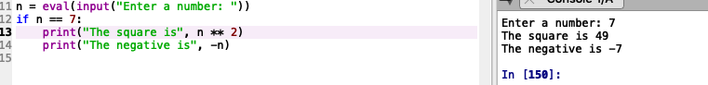

**Question#17**

**﻿Syntax Error: invalid syntax**



**Corrected block of code :**

**In Exercises 19 through 24, simplify the code.**

**Question#19**

**Question#21**

**Question#23**

**Question#25**

**Question#27**

**Question#29**

**Question#31**

**Question#33**

**Question#35**

**Question#37**

**Question#39**

**Question#41**

**Question#43**

**Exercises 3.3 : pp 111-117 Exercises 1-31 odd**

**Question#1**

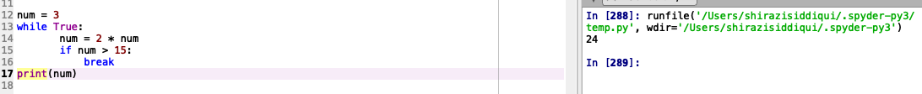

**Question#3**

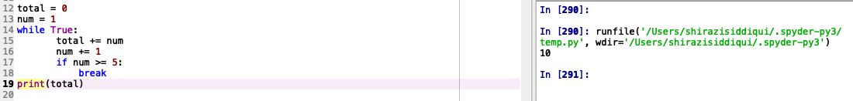

**Question#5**



**Question#7**



**In Exercises 9 through 12, identify the errors:**

**Question#9**

**Issue : Infinite loop**



**Question#11**

**Issue : i should be initialized to -1 in order to iterate over all the elements.**



**In Exercises 13 and 14, write a simpler and clearer code that performs the same task as the given code.**

**Question#13**

**﻿**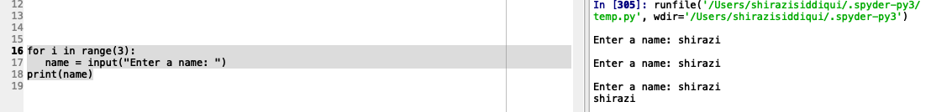

**Question#15**

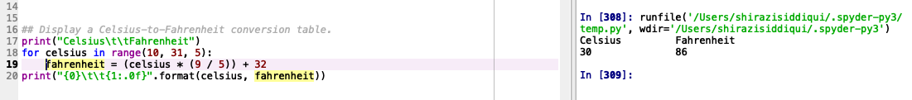

**Question#17**

**Question#19**

**Question#21**

**Question#23**

**Question#25**

**Question#27**

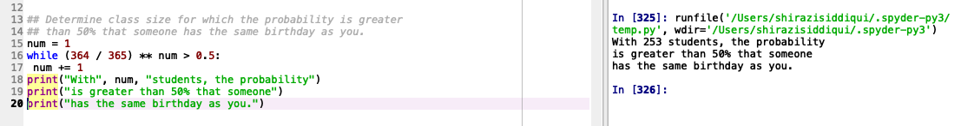

**Question#29**

**Question#31**

**Exercises 3.4 (pp 127-136 Exercises 1-83 odd)**

**In Exercises 1 through 8, determine the sequence generated by the range function.**

**Question#1**



**Question#3**

**Question#5**

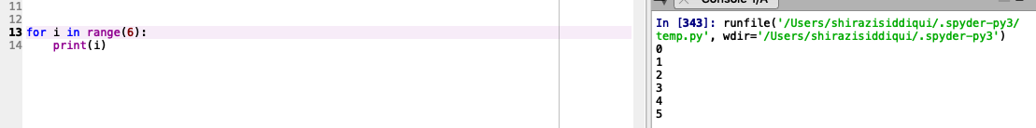

**Question#7**

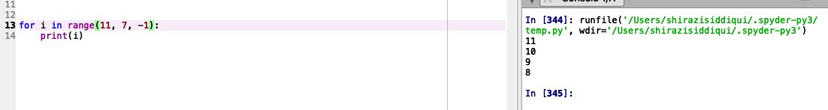

**In Exercises 9 through 16, determine a range function that generates the sequence of**

**numbers.**

**Question#9**



**Question#11**

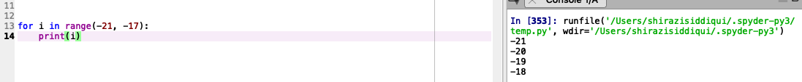

**Question#13**

**Question#15**

**In Exercises 17 through 40, determine the output displayed.**

**Question#17**

**Question#19**

**Question#21**

**Question#23**

**Question#25**

**Question#27**

**Question#29**

**Question#31**

**Question#33**

**Question#35**

**In Exercises 37 and 38, assume that the six lines of the file Numbers.txt contain the data 6, 9, 2, 3, 6, and 4.**

**Question#37**

**In Exercises 39 and 40, assume that the 50 lines of the file States.txt contain the names of the fifty states in the order they joined the union.**

**Question#39**

**In Exercises 41 through 46, identify all errors.**

**Question#41**

**Error :** The range generates no elements because the step argument’s direction is opposite the direction from start to stop.

**Question#43**

**Error :** The print function call is missing parentheses “( )”.

**Question#45**

**Error :** The range constructor should read range(0, 20) or range(20) because range(20,0) will not generate any values. Also, the print statement must be indented twice so it belongs to the if block.

**In Exercises 47 and 48, rewrite the program using a for loop.**

**Question#47**

**Simplify the programs in Exercises 49 and 50.**

**Question#49**

**Given:**

**Simplified:**

**In Exercises 51 through 65, write a program to carry out the stated task.**

**Question#51**

**Question#53**

**Question#55**

**Question#57**

**Question#59**

**Question#61**

**Question#63**

**Question#65**

**Question#67**

**Question#69**

**Question#71**

**Question#73**

**Question#75**

**Question#77**

**Question#79**

**Question#81**

**Question#83**

**pp 139-142  Choose 4 programming projects to complete**

1. **Car Loan :**

1. **Quadratic Equation**

1. **Caffeine Absorption**

**8. Palindrome**

